Introduction: The Only 5 Web Design Skills That Matter
0:00
In this video, I'm gonna show you the only five web design
0:03
skills that actually matter.
0:05
You can usually tell right away if a site was built by a pro or by
0:08
somebody who's still kind of figuring it out, and it's easy to think that
0:11
that takes a ton of different skills.
0:13
After 10 years of reading books, taking courses, and plain old building a ton
0:18
of websites, I can actually tell you there are really just five things you
0:22
need to know by the end of this video.
0:24
You're gonna know exactly what to focus on to level up fast.
0:27
And finally, feel confident as a web designer.
0:30
Are you ready?
0:31
Let's go.
Mastering Typography: The Foundation of Great Web Design
0:34
First up, are your typography skills outside of white space?
0:37
Text takes up the most real estate on your website, but 99% of web designers
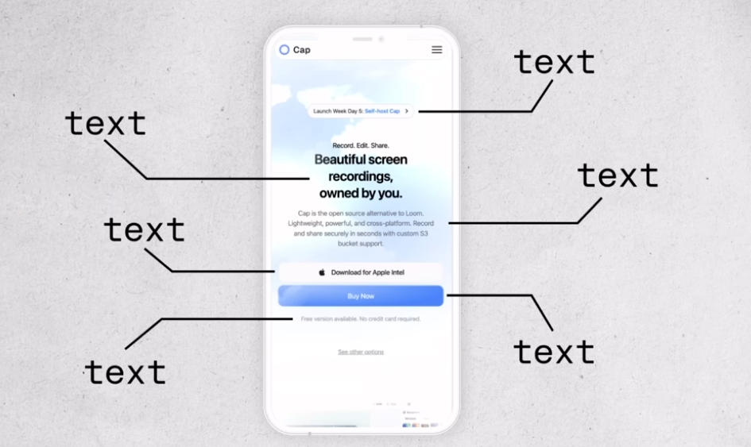
0:43
can't tell the difference between bad type choices and good type choices.
0:47
They might be able to feel when something's off, but
0:50
it just kind of stops.
0:51
There.
0:51
But here's the good news.
0:52
You actually only need to answer two questions to master
0:56
typography for websites.
0:58
And when you can do that confidently on every project, you'll be in
1:01
the top 1% of web designers.
1:04
So question number one is, how do I pick the right fonts for my project?
1:09
Most web designers use the same free fonts.
1:12
Over and over again.
1:14
And when you use those same fonts as everyone else, your designs start to
1:18
blend in, not stand out, so you gotta find fonts from places that aren't overused.
1:23
Two of my favorite resources are font share.com and uncut.wtf.
1:30
Font share is clean, high quality, and completely free to
1:35
use while uncut is a bit more.
1:38
Experimental, but they're both packed with personality and tons of free fonts to use.
1:44
Oh, and I've got a running list of free and affordable fonts
1:48
that I found out in the wild.
1:50
Every one of them are Chefs Kiss.
1:52
So you're gonna find the link to that list in the description of this video.
1:57
Oh, and by the way, make sure that you like.
1:59
And subscribe so you don't miss another episode.
2:02
And if you want the slides that I use to teach these five skills, there's
2:05
a link for those in the description.
2:07
Question number two is, how do you set up your fonts in such a way that
2:12
it actually improves your design and makes your site easier to use?
2:16
If you've ever looked at a site that was designed by a true web pro,
2:20
you're gonna notice something, right?
2:21
All the text fields.
2:22
Cohesive yet predictable without feeling super robotic, like you're
2:27
kind of reading a Wikipedia page.
2:30
That's because pro designers use something called a type scale system,
2:34
and it's just a simple set of rules that determines things like font
2:38
sizes, letter spacing, and line height.
2:41
And once you've set it up, your typography starts to feel intentional
2:44
instead of just eyeballed.
2:46
Let's start with font size.
2:48
What you wanna do is pick a base font size for your paragraph text.
2:54
Typically, people start with about 16 pixels, and then you use a scale to
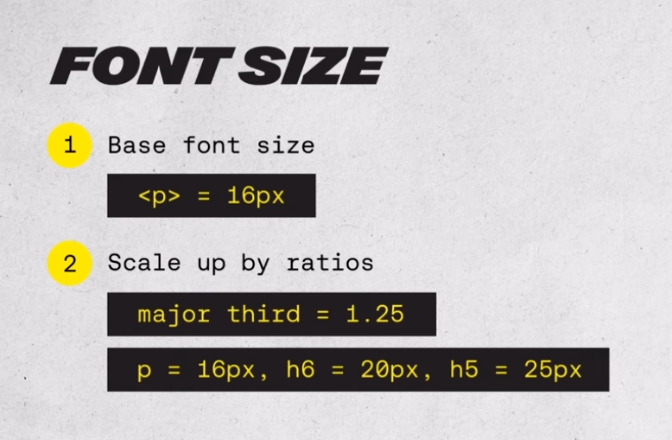
2:59
make your headings consistently larger.
3:02
A popular one is called the Major Third Scale, and if you've ever learned.
3:06
An instrument, this might sound a little bit familiar.
3:09
All it means is that you're actually going to scale up in size from
3:15
one text to the next by about 25%.
3:18
So if your base size is 16, your H six would be.
3:22
20, and then your H five would be 25, so on and, and so forth until you
3:27
reach your H ones and you actually don't have to calculate this manually.
3:32
Instead of using pixels, just use the REM values, it does all the
3:37
calculations right there for you.
3:39
Next up is letter spacing for, for body text.
3:43
Don't touch it, right?
3:44
We want that to be super legible and so just keep it the default.
3:48
But for headings, you wanna tighten it up a little bit.
3:50
As they get bigger, as text gets larger, it often looks cleaner
3:55
with slightly reduced spacing.
3:57
And then finally, line height for paragraphs go with
4:00
about 150% of the font size.
4:03
So if the font size is 16 pixels, then you would take that and then multiply it
4:08
by 1.5 to get your line height that gives the text room to breathe and makes it.
4:13
Easier to read.
4:14
And then as text gets bigger, like with headings, you can tighten up
4:18
the line height a bit to make it feel a bit more impactful and scannable.
4:22
Now, if all that sounds like a lot, here's a shortcut.
4:25
Go to type scale.net.
4:27
You pick your base size.
4:29
Choose a ratio and then it just generates the whole system for you.
4:33
It takes two minutes and makes your typography look like a pro.
4:36
Set it up.
Perfecting Layout: Structure, Spacing, and Visual Hierarchy
4:37
Next up is layout.
4:39
Most new web designers just kind of drag things around until it feels right,
4:43
and hey, you might even be following some design rules without realizing,
4:47
but pro designers don't guess about where things should go on the page.
4:51
They have systems that guarantee it.
4:53
Every time, and you actually don't need to memorize a ton of layout rules.
4:57
You just need three things.
4:58
A grid system for structure, a spacing system for rhythm between elements
5:03
and even vertical spacing, and then visual hierarchy to guide the eye.
5:08
Let's start with the grid.
5:10
Think of this as your layouts foundation.
5:12
I like to use a 12 column layout on desktop.
5:15
Eight columns on tablets and then four columns on mobile.
5:19
Why is that?
5:20
Well, because it's super flexible to divide evenly to where you don't
5:24
have to have 12 columns specifically.
5:27
It could be two columns that take up six columns on the right
5:30
and six columns on the left.
5:31
And then you can make it three or four.
5:33
It's just easy to work with.
5:35
FMA actually makes this super simple to set up.
5:38
All you have to do is select your frame, come all the way down to layout
5:42
guide, add the plus sign, change grid to columns, and then add the amount of
5:46
columns that you're wanting to work with.
5:48
Next up is spacing, and this is what gives your design room to breathe.
5:53
I use what's called an eight point grid system, and it just means that your
5:57
spacing is always multiples of eight, like 8, 16, 24, 32, so on and so forth.
6:04
It's the same approach that's used by Google for material design and Apple
6:10
in in their design systems as well.
6:12
And if major players like Google and Apple are using it.
6:15
Then you know you can't ignore it.
6:17
This is also super easy to set up.
6:19
You do the same thing in Figma as if you're setting up columns, but then
6:23
when you add a guide, you just remain on grid and then change the size of the
6:28
grid to whatever you're wanting to use.
6:30
The last piece is visual hierarchy, because here's the
6:33
truth, people don't read websites.
6:35
They scan them.
6:37
So your layout needs to guide the eyes from the things that
6:40
are most important to things that maybe don't matter all that much.
6:44
Here are a few quick principles to do just that.
6:46
Use proximity, so keep related things close together as if they're
6:51
in the same space on a page.
6:54
Then use size to tell users what's more important or least important.
6:59
You can see that this website's done a good job with that on their big.
7:04
Text and the big image down here use contrast, right?
7:08
You can use size, weight, or color, and you can see that this website's done
7:13
that really well with the opacity of their headers versus their body text.
7:18
So they're signaling to you that they really want you to read this and this
7:21
other stuff might not be that important.
7:24
And then alignment, because clean lines always equal.
7:28
A clear structure.
7:30
When you use those four together, you're gonna build a layout that feels
7:33
effortless to navigate, and that's what separates the pros from the beginners.
Color Theory: Using Color Intentionally
7:38
Next up, let's talk about color.
7:39
For a lot of designers, this is where things start to feel really
7:43
overwhelming because there are millions of colors out there.
7:46
So how do you know what works?
7:48
Here's the secret.
7:49
Pro designers don't use more color.
7:52
They use color more intentionally.
7:54
Let me show you some quick wins that are gonna instantly level up your color game.
7:58
First, you want to limit your color palette, right?
8:01
You don't need more than like two or three different colors for any project that
8:07
you're working on, but here's the key.
8:09
Each one should have a specific.
8:12
Job.
8:13
One of the most popular systems for creating visual balance
8:16
is called the 60 30 10 rule.
8:18
So 60% are your neutral colors.
8:22
Those are things like your whites and your blacks.
8:24
You use that for your background and your text.
8:27
30% are your secondary colors, and you use those for maybe different.
8:31
Backgrounds or cards, headers or visuals.
8:34
And then finally, the 10% is your accent colors, and that's what you
8:39
use if you want something to really stand out like buttons or CTAs.
8:43
But that's all you need really.
8:44
As you get more confident with color, you can expand your palettes,
8:48
but don't feel like you need to.
8:50
Another tip is use opacity rather than adding more colors.
8:54
To your palette.
8:55
So take your primary color, like this yellow here, and then just
9:00
scroll down on the opacity to create different color layers.
9:04
This is something that I actually learned when I was looking through
9:07
Google's material design and noticed that they used opacity to create a
9:11
lot of different color variations.
9:13
So one good color used well beats five random colors.
9:16
Any day.
9:17
Next, you wanna prioritize contrast, and this one's huge and it's one
9:21
that a lot of new designers miss.
9:23
Your color combo might look nice, but if your users can't read it,
9:27
it doesn't matter how pretty it is.
9:29
So always check your color Contrast.
9:32
Color contrast is the contrast between your foreground text and.
9:36
Background color that it sits on and, and you can see here that passable
9:40
contrast is three to one on larger text and 4.5 to one on smaller text.
9:47
Figma has a contrast checker baked right into its color system.
9:51
All you gotta do is select the text that you want to check, go to fill,
9:54
and then there's a contrast icon right in the top right hand corner.
9:58
It'll tell you whether or not it passes or doesn't.
10:01
It's a great tool.
10:02
Finally, don't build color palettes from scratch.
10:04
Most great color palettes weren't made out of thin air.
10:07
They were borrowed and then refined.
10:09
You can actually find any sites color palette with a tool called CSS Overview.
10:14
All you've gotta do is go to Chrome Developer Tools and then select
10:19
the three dot option right here in the top right hand corner.
10:22
Scroll down, go to more tools, and then you'll see CSS overview.
10:27
Capture the overview, and then it'll give you all the colors for that specific site.
10:31
It even gives you fonts, it gives you size settings.
10:35
It gives you the type scale system.
10:37
It's such a great tool to use.
Coding Basics: Essential Skills for Web Designers
10:39
Now let's talk code.
10:40
And I know code Boo hiss, we don't need that anymore.
10:44
But here's the truth.
10:45
If you want to be better than 99% of the other web designers out
10:48
there, you're gonna need to at least get comfortable with it.
10:51
But you don't need to know how to build a full web app.
10:54
You just need to know the basics and then know how to use the right.
10:57
Tools to get you the rest of the way.
10:59
Start with the essentials, right?
11:01
You've got HTML for structure, CSS for style.
11:05
Then there's JavaScript for interaction.
11:08
And if you're working with platforms like WordPress, PHP Basics can go a long way.
11:13
That alone is gonna take you further than most web designers.
11:16
Would ever go.
11:17
I started with free courses on Code Academy and then I would learn more as
11:21
projects that I worked on needed it.
11:23
And once you get the basics down, here's the real trick.
11:26
Find solutions that are about 80% of the way there, and then vibe, code, the rest.
11:32
So what do I mean by that?
11:34
Use code pens or snippets, even chat GPT, right?
11:37
Whatever gets you close, and then you just tweak it until
11:40
it does what you want it to do.
11:41
I had a friend who's not a developer who customized WordPress WooCommerce
11:45
plugin to have a custom checkout process for his wife's website.
11:50
You don't need to be a full stack developer.
11:52
You just learn by doing.
11:54
Don't overthink it and use the tools that are available to you.
Conversion Skills: Designing for Action
11:57
And finally, the fifth skill to stand out as the top 1% of all
12:02
web designers conversion skills.
12:05
Most designers design for looks, but pro designers design for action.
12:10
Early in my career, I redesigned a client's website from the ground
12:14
up and it looked amazing, right?
12:16
Way better than the original.
12:19
But here's the problem.
12:21
After we launched, their sales plummeted.
12:24
Why?
12:25
Because I had focused so much on the design that I ignored the user journey,
12:31
and that was a turning point for me and a really hard lesson to learn.
12:34
So let's talk about what conversion thinking really means.
12:39
First, every page needs to have.
12:41
Just one goal, right?
12:44
That's it.
12:45
And that goal should be simple.
12:46
You either want somebody to buy a product, sign up for a phone call,
12:50
or get a lead magnet, and that's it.
12:54
You lose users when you're trying to do too much at once.
12:57
Second.
12:58
You.
12:58
You need to have clear strategic CTAs and they need to be visible within
13:04
seconds of someone landing on the page.
13:07
I like to include a clear CTA in the hero section, one in the
13:11
navigation, and then one about every two or three seconds as a user.
13:17
Scroll down.
13:18
Third, it's about trust, clarity, and maybe most importantly feelings.
13:24
You probably heard it said that people buy from brands that
13:28
they know, like, and trust.
13:30
But I like to take it one step further.
13:33
They need to know, like, trust and feel something from you.
13:37
Your site has to speak to real motivations.
13:40
Clearly explain what they're getting and it needs to show
13:42
them that they're not alone.
13:44
And that's where things like testimonials and reviews and social
13:47
proof can really come in handy.
13:49
So there you go.
Conclusion: Focus on What Matters
13:50
Those are the five skills that separate beginner designers from the top 1%.
13:55
And if you're still trying to learn absolutely everything.
13:58
Take this as your permission to just stop.
14:01
Focus on these, right?
14:03
Build around them, and you'll grow way faster than chasing every single trend.
14:07
Hey, I hope this video was helpful.
14:09
If it was, make sure to hit that like button and subscribe so you don't miss
14:13
another episode that we've got coming out and hey, go design something great.
14:18
Don't forget, if you don't quit, you win.

